XVIII Children and Youth International Choreography competition

24th – 27th April 2025

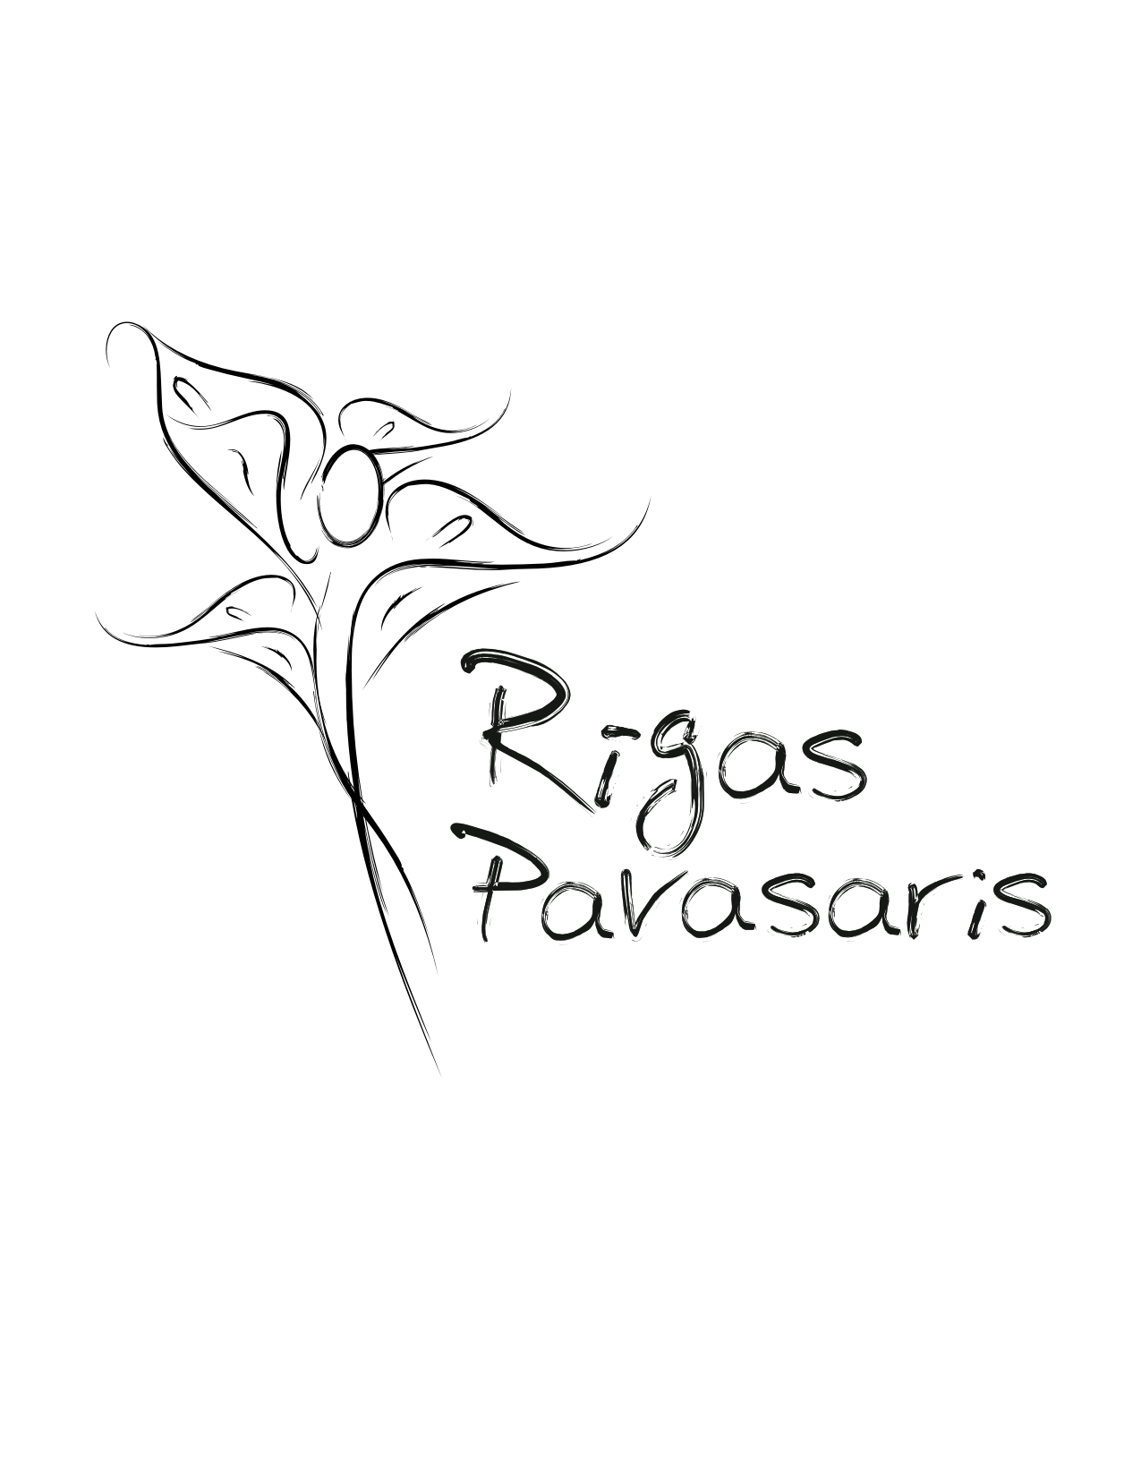

Information:
mob: +371 29203905
e-mail: tan@4nets.lv
web: www.artriga.lv , www.rlb.lv


Bērnu un jauniešu starptautiskā biedrība
“EVENTUS”
(Profesionālā radošā apvienība)
___________
Reģ.№.40008088421, Rīga, Anniņmuižas iela 4-84, LV-1029
tālr. + 371 29203905, e-pasts: tan@4nets.lv ; www.lbn.lv; www.artriga.lv

XVIII Children and Youth international choregraphy competition
”Riga spring 2025”

International Contest allows young performers and choreographers to know and evaluate one another, as well as consultation to establish joint projects and share their experiences in return.

The contest participants will be assessed by a professional jury of the Latvian and foreign choreographers, as well as contemporary art specialists.

Aim:
- Popularize the meaning of dance in harmonic personality development.
- Stimulate new and creative dance choreography development.
- Encourage dance association and educator international cooperation and exchange of experience.

Contest programme:
*Organizer has rights to change time and place for event!
24.04.25. – master classes and workshops, rehearsal – please, by appointment: tan@4nets.lv (LBN, Merkela str. 13, Riga)

    - 14:00 o’clock – press conference
25.04.25. – ”Latvian Society House”, *Classical and Folke dance contest
26.04.25. – ”Latvian Society House”, *Contemporary, Modern, Jazz and Chareographers contest

- Contests timeframe – 09:00-20:00, „Latvian Society House”, Merkela Str. 13 Riga.
- Stage parameters:
  - Size12x12m, (total area 140 sq.m.)
  - planking of special wood
  - covering – professional linoleum
  - sound producer
  - lights technician

27.04.25. ~14:00 - 18:00 o’clock – Gala, Award ceremony , „Latvian Society House”, Merkela Str. 13, Riga.
Competition progam and information about master classes and workshops, Jury Committee are published in March 2025.

All participants provided a broad program outside the competition:
Master classes and performances.
The boundaries of the project has expanded considerably, and even, in some of its characteristics, it becomes more like a festival of works by young choreographers, rather than on competition with clear winners.
However, the jury, based on their professional experience, will be called upon to determine the most promising young talented choreographers, capable in the future affect the development of modern dance.
Participants are able to attend excursions covering the old town of Riga.

Organizers:
- International Association of Children and Youth „Eventus”.

Partners:
- Riga Ballet School
- Jazeps Vitols Latvian Academy of Music
- Latvian Society House
- RJK

Art directors of competition:
Assoc.prof. Zita Errs (from 2008) – Jazeps Vitols Latvian Academy of Music, teacher of choreography department.

Director of competition: Tatyana Stepanova, art historian, director of BJSB „EVENTUS” Professional Association.
Jury Committee 2004-2024:
Zita Errs – Prof. Zita Errs (from 2008) – Jazeps Vitols Latvian Academy of Music, teacher of choreography department.
Nina Ananiashvili – People's Artist of USSR, Georgia, Russia; Georgian prima-ballerina and the Artistic Director of the Ballet company of Z. Paliashvili Opera and Ballet Professional State Theatre; the art director of V. Chabukiani Tbilisi ballet art state school (Georgia);
Viesturs Jansons – premier danseur and the teacher of Tallin State Ballet school (Estonia);
Aivars Leimanis – Latvian National Opera ballet artistic director
Irina Chistyakova – Educator and coach of Mariinsk Theatre.
Jeļena Perļina - Assoc.prof., Moscow Academy of Ballet, head of choreography department.
Igor Grigurko – choreographer, profesor, producer and art director of NELLI DUGAR-JABON PLASTIC DRAMA THEATRE „CHELOVEK” (St. Petersburg)
Regina Kaupuza – Coach of Latvian National Opera, Manager of Riga Choreography School, Educator of Latvian Music Academy department of choreography, president of Latvian Balet and Dance Guild
Juris Kaprālis – educator of Riga Choreography School, profesor of Latvian Music Academy department of choreography.
Gunta Bāliņa – Prof., lecturer of choreography department, Latvian Academy of Culture, educator of dance in Daile Theatre.
Natalia Kasparova - choreographer, ”Kannon Dance” ballet manager, B.Eifman Dance Academy modern dance teacher (St. Petersburg).
Luana Luciani - a member of the dance commission with the Italian Ministry of Culture since 2009; Association of Culture DanzaSi president, Chief editor of the monthly choreography journal, Head of dance competitions: "Classical Dance Competition in Rome", "DanzaSi non solo jazz" since 1999; Organises dance performances and festivals, including "City Colors", "E solo Funk", "Ciao Rafaello"; Member of the jury in Spanish and Italian competitions (Italy);
Vladimir Adjamov – choreographer, honorary artist of Russian Federation, Adjamov foundation director, president of Saint Petersburg Choreography Association (Russia);
Marek Rózycki – Deputy Artistic Director of Berlin State balet School (Germany);
Yury Petukhov – Prof. The Vaganova Academy of Russian Ballet , Artistic Director of the Russian Classical Ballet Palace theatre, People‘s Artist of Russia, State Prize Laureate of Russia, Laureate to International Ballet competition (Russia);
Georgy A. Kovtun – Associate Professor of Rimsky-Korsakov St. Petersburg State Conservatory Department of Ballet Direction, Honored Art Worker of Russia, Choreographer and Stage Director (Russia);
Gyuzel Apanaeva – People’s Artist of Russia, Director of Moiseyev Dance Academy;
Marguerite Donlon - dancer, choreographer and Donlon ballet director (Germany);
Stefania Pigato – Choreographer and teacher of modern dance, Vicenza (Italy). The Artistic Director of The Bridge Pigato Contemporary. The creator of the Pigato Contemporary method (Italy);
Emi Hariyama – ballerina and Director of the Emi International Arts and professor at Kobe collage (Japan);
Kenneth Ludden – Director of Margot Fonteyn Academy of Ballet (USA) and The Patron of Melnbourne Academy of Arts (Australia);
Philippe Lormeau – Prof. Liones Conservatory , head of choreography department (France);
Rainer Krenstetter – a principal dancer with the Miami city ballet (USA);
Sławomir Gidel – Artistic director at Ballet School in Gdansk (Poland);
Natalia Permyakova – A candidate of pedagogical sciences, a corresponding member of the International Academy of Pedagogical Education Sciences, and head of the classical dance department of the Russian State Dance Academy Boris Eifman (Russia);
Joseph Morrissey – Director of Dance at the Interlochen centre for Arts, formally the Director of Artistic Planning and Touring for the Hong Kong Ballet. Danced with the Bavarian State Ballet, the Boston Ballet and the Charleston Ballet Theatre (USA);
Andrej Litvinov – People's Artist of Republic Moldova, Ballet dancer at National Opera, art director and Balletmaster at National Opera Chisinau, Chisinau State Choreography colleges teacher (Republic Moldova).

Jury Committee 2025 – www.artriga.lv

Conditions of contest participation:
The invitation to the contest include the three levels: 1. Video, 2. Contest And 3. Contest

I Amateur contest
Private schools, studios.
- Premiere competition
- Length of performance – max 3 min
  - Solo max 3 min
Genre: classic dance and stylization, character dance and stylization, contemporary, modern dance and stylization (mix age group children dances. Various lifting elements are allowed (except for children up to 7 years of age) and acrobatic techniques)
- One dance in each nomination
- Music accompaniment – separate for each dance

Age Groups:
- 7-11 y.o.
- 12-14 y.o.
- 15-17 y.o.
- 18-26 y.o.
- Mix age group

II Professional state school contest
- Premiere competition.
- Length of performance:
  - Solo max 3 min
  - Duo max 11 min
  - Group max 4 min
- Genre: classic dance and stylization, character dance and stylization, contemporary, modern dance and stylization.
- One dance in each nomination
- Music accompaniment – separate CD for each dance

Age Groups:
- 12-14 y.o.
- 15-17 y.o.
- 18-26 y.o.

III Professional choreographers contest
- Main objective - to find opportunities for young talented choreographers to test their skills and creative insights of modern art of dance on the large stage

- Entries must be notified within three nominations separately:
1. Classical dance and stylization
2. Folk dance theatrical and stylization
3. Modern dance and stylization

- Production footage: A group – Solo, duo, small groups: 3 minutes up to 6 minutes (26.04.25. Riga, Merkel str.13.); B group (large format) up 6 to 10 minutes (26.04.25. Riga, Merkel str.13.)
- Contest is open to choreographers aged 18 years who submit an application during the competitive Organizing committee and undergo a selection contest

Evaluation:
Evaluation will be in 10 grade system
Results of competition will be published after the competition
Jury has rights to award extra special nominations

Evaluation criteria:
- Artistic performance in general
- Technics of performance
- Composition
- Choreography and harmony with music accompaniment
- Conformity of repertoire with dancers’ age individualities
- In competition will be evaluated work of choreograpers-educators and custume designers
- Choreographers’ art: style/idea/novelty

Award ceremony:
- Grand Prix – 1000 Eur of the three categories
- 1 Prix – for each nomination
- Special prizes from jury

All participants of the final will receive official participation certificates as well as memorable gifts

Applications:
- Participants are registered only with prior application
Applications, Videos and DVD records must be sent to organizers until 28th February 2025!
(address: Anniņmuižas Str. 4-84, Rīga, Latvia, LV-1029), to email address: tan@4nets.lv
- Decision about participant participation in final is taken by members of jury. Information about participation in final will be sent to participants address!
- Telephone no. for further information: mobile: + 371 29203905 – Tatyana Stepanova.

Visa: Please state exact group data as in example (see attachment no.1 + Surname, Name of responsible person for children health and confirmation of funding) until 28th February 2025 (tan@4nets.lv)

Responsibility:
- The presence of group leaders and soloists at the introductory meeting is mandatory.
- RIGHTS OF THE JURY AND ORGANIZERS
- The organizers of the competition are the International Children's and Youth Society "Eventus".
- The jury's decision is binding and cannot be challenged.
- Copyright: All multimedia materials created at the festival are considered the property of the organizers. It is allowed to use and reproduce this material only with the written permission of the organizers. Either photo or video recording has to be paid for. It is possible to obtain DVD from organizers of competition
- Attention to the participants! The organizers of the competition have the right to suspend groups or soloists from participation for an offensive statement or action directed against other participants, organizers, jury, guests of the competition.
- Strict routine of competition is mandatory for all participants and managers.
- !! Participants are responcible for arranging their own private insurance:
- Insurance policies for all participants are required, as well as a vaccination passport against Covid19, a negative test for Covid19, made 3 days before arrival, at the participants expense. Medical masks must be worn for everyone in transport and indoors (* the rules are subject to change).
- Observation of safety and behavioural rules during competition and accomodation at hotel are mandatory to all participants. Organizational committee of competition provides presence of medical staff during the competition, buti s not responsible for possible accidents.
- Organizational committee of competition provides security staff for participants, but is not responsible for personal belongings during the competition event in halls or outside them.
Name of institution:
Signature of institution director:

Date: 28th February 2025

Details of institution:

XVIII Children and Youth international choregraphy competition
”Riga spring 2025”

APPLICATION

(Еach dance separate)

Сontest: Performers / Choreographers
Educational institution

Аmateurs / Рrofessional group

Soloist, duet, group
Country
Address, e-mail, telephone
Group name
Manager (Surname, Name)
Telephone, e-mail
Name of performance
Genre
Choreographer
Educator
Costume designer
Author of music
Timing (Chronometry): ____:____ minutes
Start (from the point, from the backstage)

List of participants
Nr. Participant Surname, Name/ Year of birth (date/mounth/year)/ Gender of a person
1.
2.
3.
4.
5.
6.
7.
8.
9.
10.
11.
12.
13.
14.
15.
16.
Necessary technical means:

Signature of institution director:

Date:

Nr. | Surname, Name  Sex | Dates and place of birth | Passport No | Date of passport issuing and expiry | Citizenship | Address and place and address of work/ scnool

Attachment No. 1

For invitation sending, please, provide with following data.

