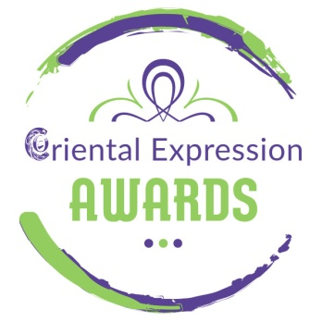
6th Spring International Bellydance Competition (March 19-20, 2022)

ORIENTAL BELLYDANCE WORKSHOPS

With Prince Kayammer and Ntia Pilatou

SATURDAY, MARCH 19th , 2022

The international artists, dancers and teachers, Prince Kayammer and Ntia Pilatou are coming to Athens invited by Anna Dimitratou and Oriental Expression Awards. The artists:

• Will teach 2 two-hour workshops (Saturday 19 March)
- Mejance with Prince Kayammer (15:00-17:00)
- Drum Solo with Ntia Pilatou ( 17:30-19:30)
• Will be honored judges at the Bellydance Competition “6th International Bellydance Competition” (Sunday, March 20, 2022, 11:00)
• will perform to the Mega Oriental Show (Saturday March 20, 20:00)

Workshops price:
- Full pass: 2 workshops + 1 Competitions participation + Show Ticket:
100€
- 2 workshops + Show Ticket:
80€
- 2 workshops + 1 Competitions participation :
90€
- 1 Workshop:
40€
- 2 Workshops:
70€

ENTRY FEES

Participation at 6th Spring International Bellydance Competition
Solo Adults: 25 €
Solo Kids : 20€
Groups (of more than 3 persons): 15€
Additional categories add 15€ per category

Info - Online Booking: Oriental Expression Awards
31 Antiopis Street, Agios Dimitrios - Dafni Metro Station
Tel. / Fax 210 9735 888 - Mob. 699 711 6407 - 699 255 3320
www.orientalexpressionawards.gr - info@orientalexpressionawards.gr

