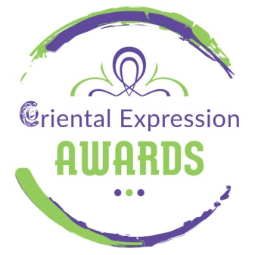
MEGA ORIENTAL SHOW!!!

SUNDAY, MARCH 20, 2022 (20:00) at “Αρχιτεκτονική - Live Stage”

With many famous dancers and choreographers!

Sunday, March 20 2022 at 20:00 in “Αρχιτεκτονική - Live Stage” a special Mega Oriental Show will take place, where the Athenian public will have the opportunity to enjoy on stage the famous dancers and choreographers:
Anna Dimitratou, Prince Kayammer, Eva Chatzichristou, Nelly Glikioti, Ntia Pilatou, Sara Toscano, Soraya Shoheib, Elisavet Dakoutrou, Maria Traka, Kalypso Mani, Niki Aspioti, Mairy Dimitropoulou, Evdokia Kalifatidou, Fenia Botsi, Maria Iosif, Maria Magdalene, Marianna Karamanakou, Natasa Danseuse, Nota Ilia, Elisavet, Pieri, Samira Masreya, Yara Dagher, Myriam Amina!

The Show is organized by “Oriental Expression Awards” within the “6th Spring International Bellydance Competition”.

During the 2-day event, the artists will:
• Teach 2 two-hour workshops (Saturday, March 19)
  - Mejance with Prince Kayammer ( 15:00-17:00)
  - Drum Solo with Ntia Pilatou (17:30-19:30)
• be honored judges at the Bellydance Competition “6th Spring International Bellydance Competition” (Sunday, March 20, 2022, 11:00)
• perform to the Mega Oriental Show (Sunday, March 20, 20:00)

INFO :
Architektoniki Live Stage (6, Elasidon str. – Gazi Area – Athens)
Tickets: 10€

Profits will be donated to the UNHCR in support of Ukrainian refugees.

Information - Registrations
Oriental Expression Awards
Antiopis 31, Aghios Dimitrios – Dafni Metro Station (Agios Dimitrios – Striggari Exit)
Tel / Fax: +30 210 9735 888 – Mob: +30 699 711 6407 – +30 699 255 3320
www.orientalexpressionawards.gr – info@orientalexpressionawards.gr

