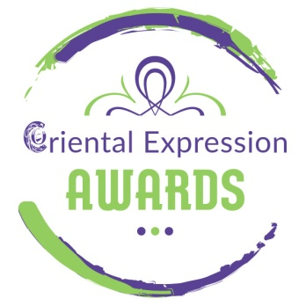
5th Spring International Bellydance Competition (March 21-22, 2020)

ORIENTAL AND TRIBAL FUSION BELLYDANCE WORKSHOPS

With Oriental Superstar Diana Gnatchenko
And the Greek Tribal Fusion Star Eva Chantzichristou

SATURDAY, MARCH 21ST, 2020 (13.00 – 19.00)

The Oriental Superstar Diana Gnatchenko is coming for the very 1st time in Athens – Greece, invited by Anna Dimitratou and Oriental Expression Awards. With her, the internationally renowned Greek Tribal Fusion Star Eva Hatzichristou.
During their stay in Athens, the artists:

• They will teach 3 two-hour workshops (Saturday 21 March, 13.00 - 19.00)
(Tribal Fusion Bellydance Workshop by Eva Hatzichristou 13:00-15:00)
(Oriental - Drum Solo by Diana Gnatchenko 15:00-17:00)
(Oriental - Baladi by Diana Gnatchenko 17:00-19:00)
• Will be honored judges at the Bellydance Competition “5th International Bellydance Competition” (Sunday, March 22, 2020, 11:00)
• They will perform to the Mega Oriental Show (Saturday March 21, 21.00)

WORKSHOP’S DESCRIPTION
- Tribal Fusion Bellydance
Stage is the space where art is happening. When we get a chance to be on stage let’s take advantage of it! We can conquer every single piece of this space and create surprises for our audience. Moving around can be uncomfortable for tribal fusion dancers that are mostly used to executing isolations staying in place. But there are great ways of travelling without loosing the unique fluid feeling of tribal fusion. In this class we will learn combos and play games to find unusual ways of getting around stage creating all kinds of shapes.
- Drum solo
The main secrets of Diana Gnatchenko, the main ideas and way to dance drum solo. How to do visible the small and detailed technique? We'll learn to fill the music correctly and use the space around yourself. Contrasting technology. What it is? How and where to use it?!
- Baladi modern
Choreography with favorite composition. We will learn hard spectacular elements, learn how to use advantageous foreshortenings in choreography, will learn through the subtleties of working with the plastic of the body, you will learn to do and understand what seems impossible. The main idea of class is music understanding and we're not going to dance with music, we will try to paint it.

Workshops cost:
Full pass: 3 workshops + participation in the competition + entrance to the Show
120 euro (till 31/10/2019)
140 euro (till 31/12/2019)
160 euro (till 21/3/2010)

3 workshops + entrance to the Show
100 euro (till 31/10/2019)
120 euro (till 31/12/2019)
140 euro (till 21/3/2010)
Individual Workshops
1 workshop (Diana) 50 euro
1 workshop (Eva) 40 euro
2 workshops 90 euro

ENTRY FEES
Participation at 5th Spring International Bellydance Competition
Adults Solo: 25 €
Kids (up to 11 years old): 20 euro
Groups (of more than 3 people): 15 euro
* To join additional categories add 15 euro per category
(Includes entry to the Mega Oriental Show on Saturday 21 March 2020)
* Viewers’ entrance for the Competition and the following Winners Parade: 10 euro
* Viewers’ entrance for the Competition and the Mega Oriental Show Saturday: 15 euro

Info - Online Booking: Oriental Expression Awards
31 Antiopis Street, Agios Dimitrios - Dafni Metro Station
Tel. / Fax 210 9735 888 - Mob. 699 711 6407 - 699 255 3320
www.orientalexpressionawards.gr - info@orientalexpressionawards.gr

