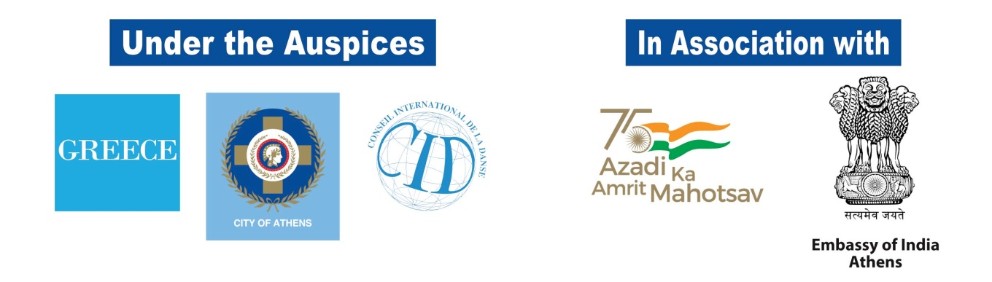
2 UNIQUE DANCE SHOWS AT DORA STRATOU THEATER
(Saturday 2nd and Sunday 3rd July, 2022)
The Main attraction of the 8th “Bollywood and Multicultural Dance Festival” in Athens, Greece, shall be the two Mega Shows on Saturday July 2nd and Sunday July 3rd from 21:00 onwards at the traditional Greek amphitheatre, Dora Stratou Theatre, in the heart of the city of Athens!
With the seductive Bollywood choreographies and the Indian element at the forefront, the founder of 1st Bollywood Dance Academy Greece Anna Dimitratou, accompanied by members of the Academy and a number of internationally recognized teachers and dancers, gradually lead us from the dance tradition of East and West as evolution of this tradition today. Thus, we will all become "witnesses" of the eternal dance creation, giving the great message that Art gives birth to civilization, unites, but above all elevates man to joy, which is his true nature!
The shows include performances from renowned artists such as the Internationally renowned Bollywood dance performer, teacher and choreographer Amit Patel from USA, the Indian Bollywood dance performer, teacher and choreographer Sumon Rudra, the Indian Classical and folk dancer and choreographer from Poland Kinga Malec, the singer and performer Sneha Mistri from Spain, Lavesh Pritmani professional dancer, choreographer and Bhangra dance teacher, Bharatanatyam and South Indian folk dancer and teacher Vinatha Sreeramkumar, Pavan Prasad Tollywood dancer and teacher from Germany, Carolina Rudio teacher and Bollywood dancer from Spain, Amine Amoura Bollywood dance teacher and choreographer from France, the exceptional Hassan Bolbol Al Tannnoura from Egypt as well as others dance groups from Greece and Abroad that will take spectators to the magical world of dance and movement.
*During both Shows, the Urban Fauna of City of Athens (Animal Adoption Program), the “Child's Voice” (Association for the Support of Children with Cancer) and the Environmental Organization WWF Hellas, will be with us!

The Festival is organized by the Artistic Studio Oriental Expression and 1st Bollywood Academy Greece, in collaboration with the Hellenic Indian Society for Culture and Development (ELINEPA), under the Auspices of the Greek National Tourism Organisation (GNTO), City of Athens and the International Dance Council (CID) and in association with the Embassy of India in Athens.

Entrance: 10 euro (1 Show)
15 euro (2 Shows)

For more information about the Festival, Competition, Workshops and tickets, please address the Organizers or visit our website: www.bollywoodfestival.gr, info@bollywoodfestival.gr

Presale:

