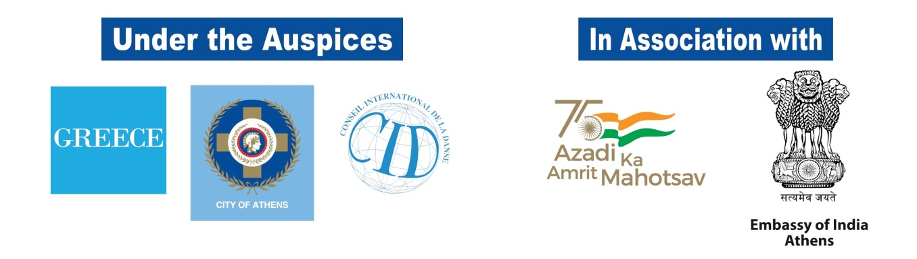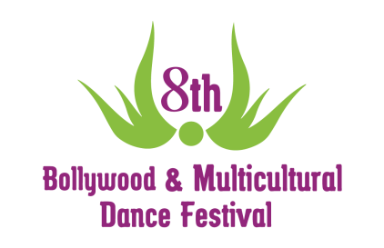
Under the verdant scenery of Filopappos hill
the 7th International Bollywood Dance Competition!!

Saturday, 2 July 2022 (19:00)

The historical “Dora Stratou” Dance Theatre hosts once more
the “7th International Bollywood Dance Competition”

The 8th Bollywood and Multicultural Dance Festival, hosts the “7th International Bollywood Dance Competition” in Greece, which is organized by “Oriental Expression Awards”. The competition will be held at “Dora Stratou” Theatre on Saturday 2 July, in front of a 10 member Panel and will be divided into two levels (amateur and professional) and two categories (solo and group). The winners will be honored with presents and awards.

Dancers of all levels from Greece and abroad are invited to show their skills and present traditional as well as modern forms of Bollywood Dance.

For more information about the categories, the price and terms of participation please visit: https://bollywoodfestival.gr/en/competition/
After the Competition ends, the great Opening Show of the Festival shall follow, featuring dance performances from acclaimed Greek and international artists.

For news and information, visit the Facebook event:
https://www.facebook.com/events/705273680519098
Entrance to the Competition and the Opening Show: 10 euro

Presale at: Viva.gr

