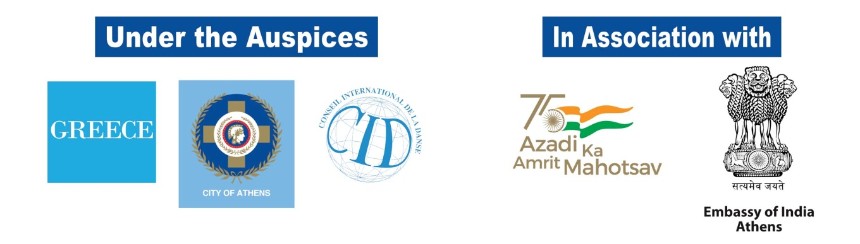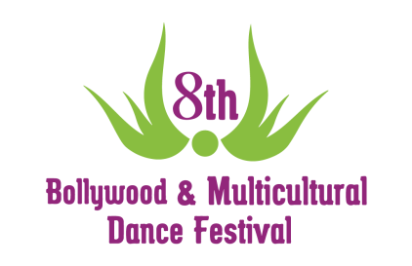
8th “Bollywood and Multicultural Dance Festival”
Under the Auspices of the Greek National Tourism Organisation (GNTO),
the City of Athens and the International Dance Council (CID)

In association with the Embassy of India, Athens

July 1st-3rd 2022 in Athens Greece
2 Unique Shows at Dora Stratou Theatre on Saturday and Sunday
East and West, two seemingly separate worlds, will come together at the biggest Extravaganza of 2022, the 8th Bollywood and Multicultural Dance Festival in Athens, Greece.

Three days of deep culture immersion, full of music, dancing, mystery, charm, and endless aesthetics.

“Greece has always been a crossroad between East and West, where diverse cultures met and have evolved over millennia. From India and Middle East to North Africa and the Mediterranean Basin, ethnically diverse communities come to close contact by exchanging various characteristics of their culture and all forms of Art. The Festival aims to highlight this magical amalgamation of cultures emphasizing the role of Dance and Music, and to provide the opportunity to discover the magic and the beauty of this peaceful gathering of nations – beyond geographical boundaries – at this modern world that we live in.”

Within the spectrum of this Festival, dancers, musicians, singers as well as intellectuals from Greece and abroad will participate. In addition, workshops will take place in combination with presentations, performance and lots of other activities.

14 DANCE WORKSHOPS

As for the educational part of the festival, the participants will have the opportunity to attend a variety of dance workshops from renowned artists from Greece and abroad, with various dance styles such as: Traditional Bollywood, Bollywood Item Song, Indian-Contemporary Fusion, Odissi Dance, Kuthu, Kathak, Bhangra, Bollywood Fusion, Tollywood, Western Fusion, Bollywood Heels, Bolly-Belly Fusion, Bolly Blast and more. The participants also get to attend the Bollywood Dance Master Training with our International Guest Teachers of "Be a Bollywood Dance Professor” program.

A glimpse into the list of the Dance Professionals this year: The founder of the “1st Bollywood Dance Academy Greece”, Teacher, Choreographer and Performer Anna Dimitratou, our choreographer,

teacher and performer, Sumon Rudra (Bollywood Item Song, Western Fusion), Amit Patel (Indian-Contemporary Fusion) from USA, Carolina Rubio (Odissi Dance) from Spain, Vinatha Sreeramkunar (Kuthu) from Spain, Kinga Malec (Κathak) from Poland, Lavesh Pritmani (Bhangra Bollywood)from USA, Sneha Mistri (Bollywood Fusion) from Spain, Pavan Prasad
(Tollywood) from Germany, ο Amit Patel (Bollywood Heels) from USA, o Amine Amoura (Bolly Blast) from France and more.

2 UNIQUE SHOWS
The Highlight of the festival is the two Amazing Shows at the historic Dora Stratou Theatre, in the heart of Athens, with the Filopappos green hill background, on July 2nd (Saturday) and July 3rd (Sunday) 2022. The audience will have a treat to witness a plethora of dance styles from all over the world and multicultural character by great artists from Greece and abroad, as well as exclusive choreographies from 1st Bollywood Dance Academy Greece.

The 7th International Bollywood Dance Competition

The Festival will host the “7th International Bollywood Dance Competition” in Greece, organized by “Oriental Expression Awards”. The competition will be held at Dora Stratou Theatre, Saturday, July 2nd front of a 9-member Judges Panel, and it will be divided into two levels (amateur and professional) and two categories (solo and group). The winners will be honored with presents and awards.

Mini Bazaar and Indian Flavors

During the Workshops, the 2 amazing Shows and the Competition, a Mini Bazaar will be operating in the Theater. At the same time, participants will be able to try Indian snacks at friendly prices by DOSA HOUSE.

The Opening Party

The Opening Party that marks the onset of the Festival is a welcome party full of dance surprises, where every friend and visitor of the Festival WILL BE THERE!!! The party will take place on Friday, July 1st, 2022 (21.00), at Antika Rock Cafe Bar!!

The Social Action of the Festival

During both Shows, the Urban Fauna of the City of Athens (Animal Adoption Program), the “Child's Voice” (Association for the Support of Children with Cancer) and the Environmental Organization WWF Greece will be with us!

The Festival is organized by the Artistic Studio Oriental Expression and 1st Bollywood Academy Greece, in collaboration with the Hellenic-Indian Society for Culture and Development (ELINEPA), under the Auspices of the Greek National Tourism Organisation (GNTO), the City of Athens and the International Dance Council (CID) and in association with the Embassy of India, Athens.

More information about the festival, contest, seminars and tickets, you can find at www.bollywoodfestival.gr

