FROM:
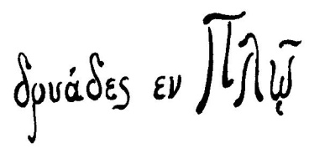 | PERFORMING ART COMPANY  Dryades en Plo  Non-profit Company
Contact person: Maria Karapanagioti
Tel: 0030 6930 434 059
Karditsa’s shopping center (1st Floor)
43 100, Karditsa, Greece
dryades.en.plo@gmail.com
www.dryadesenplo.gr
www.facebook.com/xoros.anapiria.karditsa

Subject: Invitation to participate in the 4th International Dance Festival Disability (IDFD)
The performing art company “Dryades en Plo” is inviting you to participate in the 4th International Dance Festival Disability (IDFD), which will take place in the town of Karditsa (Greece) on 29 – 30 - 31 October 2021, under the auspices and financial aid of the Greek Ministry of Culture and Sports and the Regional Directorate of Thessaly.

The festival (which will be hosted for the 8th time on national and 4th on international level by the town of Karditsa) will include a variety of performances, workshops and seminars from mixed dance groups, independent artists and experts from Greece and abroad.(More details about the program will be announced at a later time).

It will hopefully take place live with audience, following all the Covid-19 measures and government’s guidance. Alternatively, we are ready to host the IDFD online again this year, through live stream and/or recorded choreographies, as the year before.

We will be more than happy to welcome you at the 4th IDFD and celebrate with you, in these unprecedented times, a world of dance.

Registering deadline dates:
20/09/2021 (live performance)
30/09/2021 (online)

You are welcome to contact us for any further information!
On behalf of
Dryades en Plo
The President
Maria Karapanagioti
Education specialist, choreographer , dance therapist

