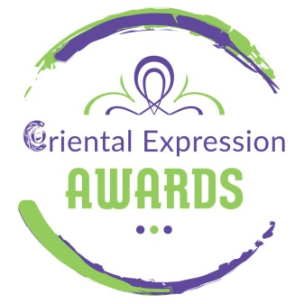
The 5th Spring International Bellydance Competition is happening in Athens!
Special Guests: Diana Gnatchenko, Eva Chantzichristou

“Oriental Expression Awards” organizes for the 5th consecutive year, the biggest International Bellydance Competition.
The competition takes place on Sunday, March 22nd 2020 at Art Space “Anna Maria Kalouta” (Timokreontos 6A, Neos Kosmos) – starting time: 11 am.

“Oriental Expression Awards” is an Institution that organizes Dance Competitions, aiming at not just promoting traditional and modern dance trends and techniques, but also at rewarding all those who serve the art of Dancing and always strive for the best.
The Competition is open to Dancers of all levels (Beginners, Advanced and Professional) from Greece and Abroad. It features all styles of Oriental dance (Folklore and Modern) as well as Tribal Fusion Bellydance.
The deadline for registrations is the 28th of February 2020 .

More info about categories, cost and terms of participation can be found here:
https://orientalexpressionawards.gr/diagonisnos-2020/

During the Competition, a Fashion Show showcasing Oriental and Tribal Fusion Bellydance costumes and accessories, will also take place.
Furthermore, a magnificent Winners Parade Show will ensue the awarding ceremony. In this parade will perform the gold winners of all categories.

For more news and information, visit the Facebook event:
https://www.facebook.com/events/638277500034346/
ENTRY FEES
Participation at 5th Spring International Bellydance Competition
Adults Solo: 25 €
Kids (up to 11 years old): 20 euro
Groups (of more than 3 people): 15 euro
* To join additional categories add 15 euro per category
(Includes entry to the Mega Oriental Show on Saturday 21 March 2020)
* Viewers’ entrance for the Competition and the following Winners Parade: 10 euro
* Viewers’ entrance for the Competition and the Mega Oriental Show Saturday: 15 euro

Information - Registrations
Oriental Expression Awards
Antiopis 31, Aghios Dimitrios – Dafni Metro Station (Agios Dimitrios – Striggari Exit)
Tel / Fax: +30 210 9735 888 – Mob: +30 699 711 6407 – +30 699 255 3320
www.orientalexpressionawards.gr – info@orientalexpressionawards.gr

